PWA Video 24-realtime-data

<https://www.youtube.com/watch?v=JP3L0jIXvrY>

While working with setting up the database comment out the fetch event listener in the service worker 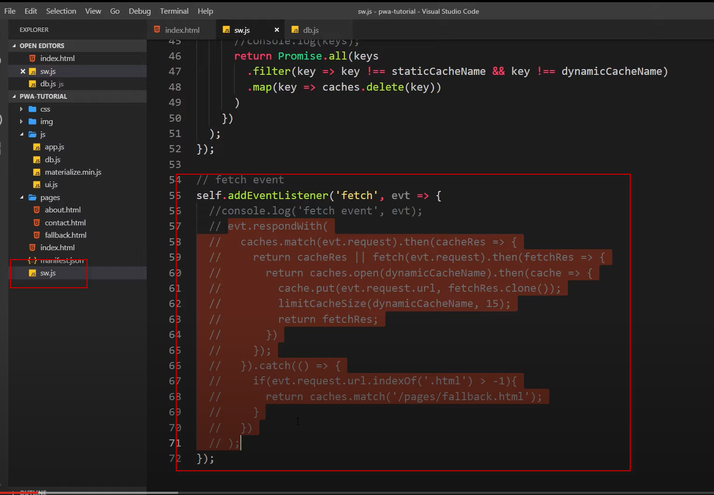

NOTE my app broke here 4 min into video - this may be due to changes in the firebase version the video is

https://www.gstatic.com/firebasejs/5.11.0/firebase-app.js

now it is on v 8

    <script src="https://www.gstatic.com/firebasejs/8.0.0/firebase-app.js"></script>

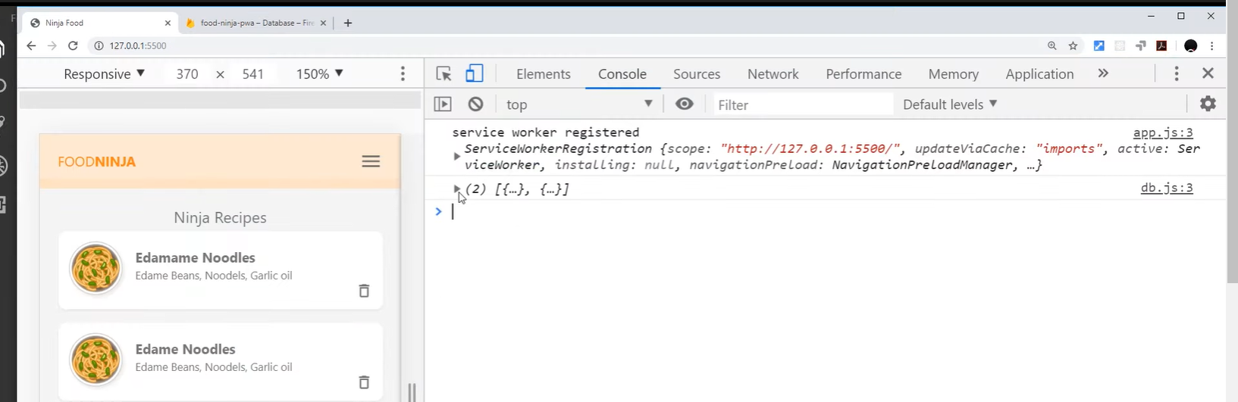

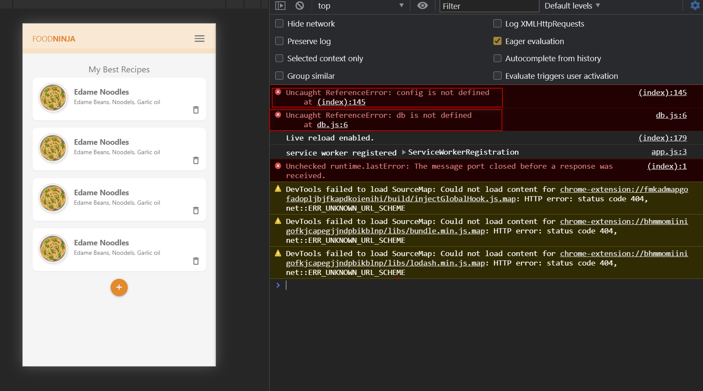

Seeing types as added in the snap shot

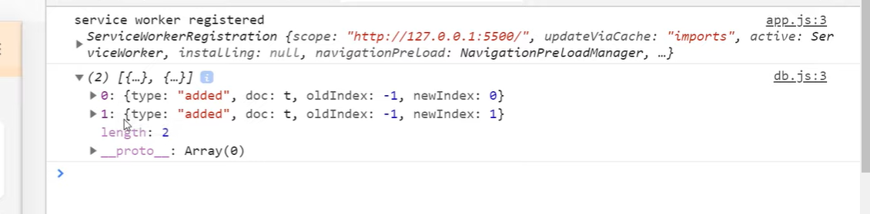

After initial we get back more after changes

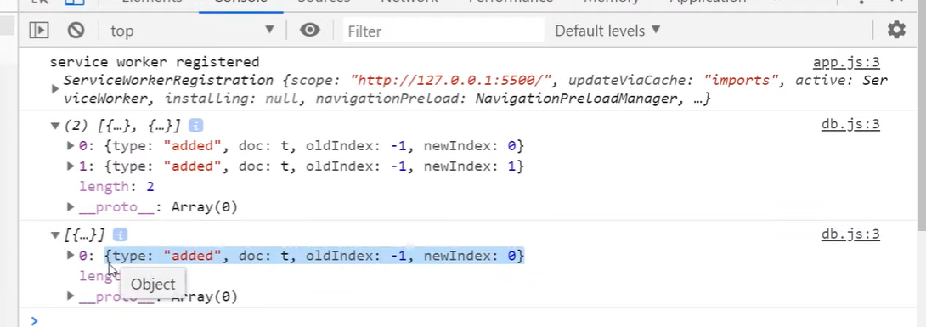

Same with deletions 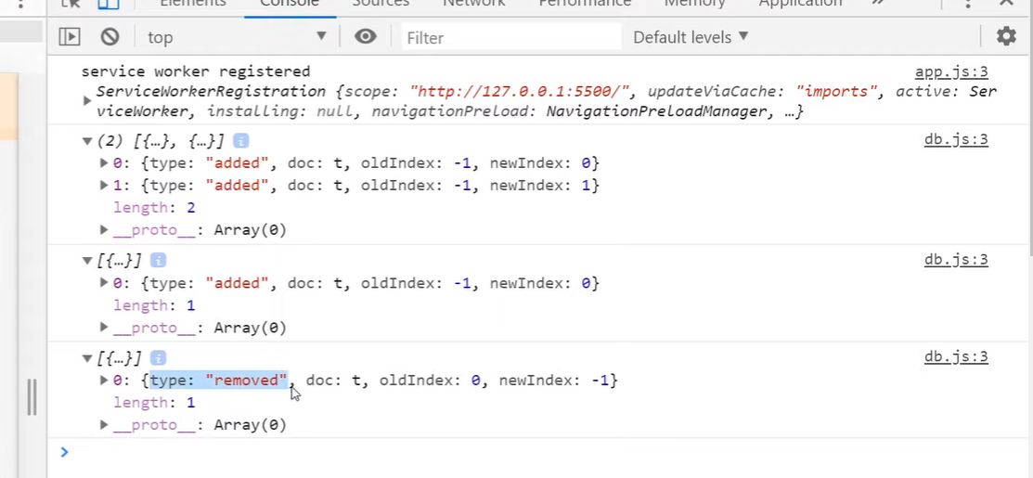

UI in sync with DB by listening for the changes

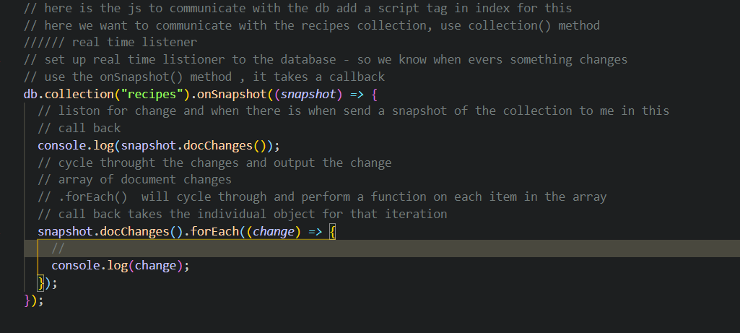

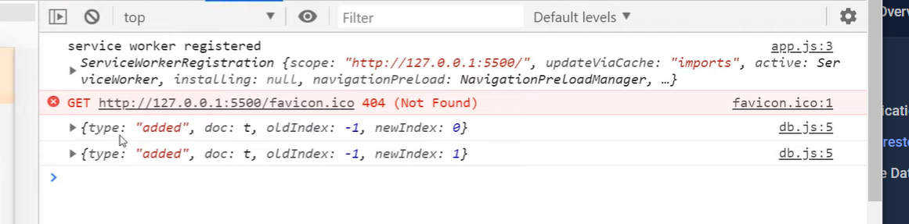

Can access via a method on the doc property data 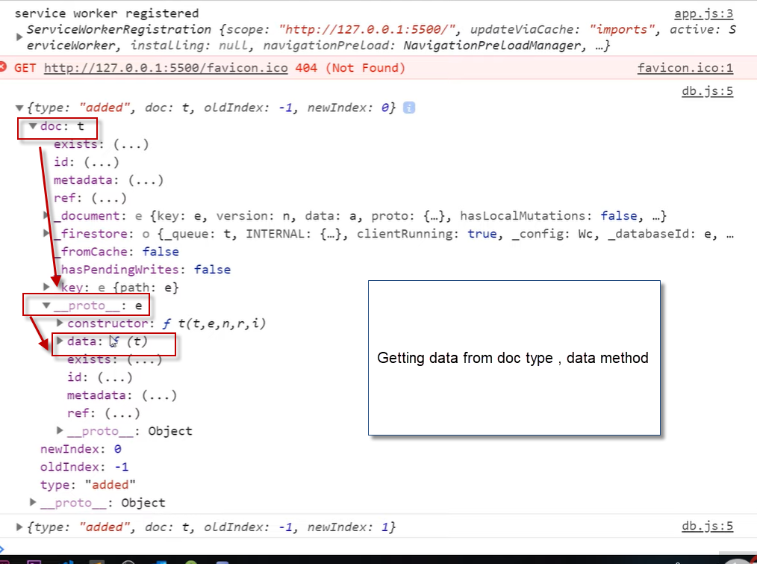

Using this can get to the ingredients and title – data inside each change

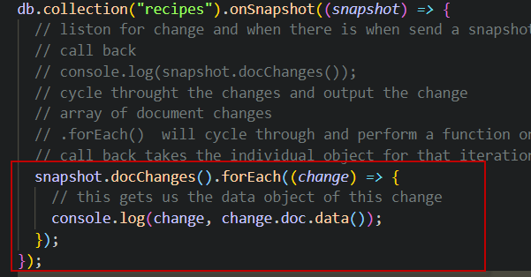

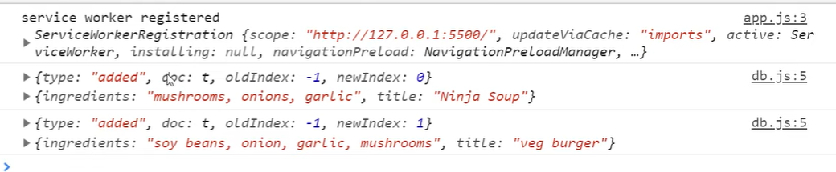

Take this data and output it to the DOM

Can access the ID in this way